***ADVANCE LINUX***

**Ques 1:-** What is the size of MBR and what does it contains

Ans 1:- Size of an MBR is 512 bytes & it contains the information of the first sector of the hard disk where the operating system is located and access ram.It also contains master partition table.

**Ques 2:-** In which file you can write commands which you want to run whenever Linux system starts/restarts?.

Ans 2:- .profile

**Ques 3:-** Reboot the system using runlevel.

Ans 3:- **init 6** runlevel is use to restart the system

Runlevels define what tasks can be accomplished in the current state (or runlevel) of a Linux system

* 0- Halt
* 1- Single user mode (recovery)
* 2- Debian/Ubuntu default
* 3- RHEL/Fedora/SUSE text mode
* 4- free
* 5- RHEL/Fedora/SUSE graphical mode
* 6- reboot

**Ques 4:-** Restart cron service.

**Ans :-** 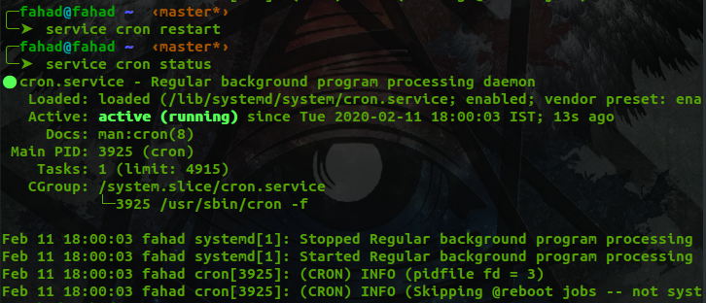

**Ques 5:-** Create an ext4 filesystem

**Ans :-** First we have to create a partition by **sudo fdisk /dev/sda**

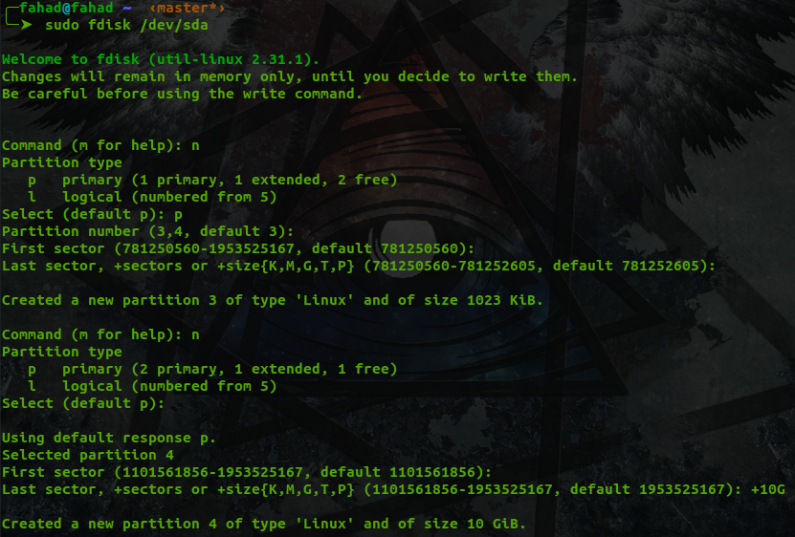

Now we have to list all the partition by pressing **p**

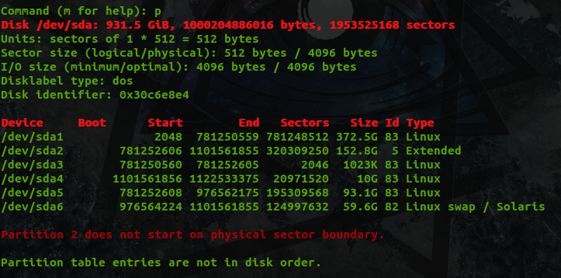

Now to write and exit type **w**

To create a file system of **ext4** we have to type command **mkfs.ext4 <partition name>**

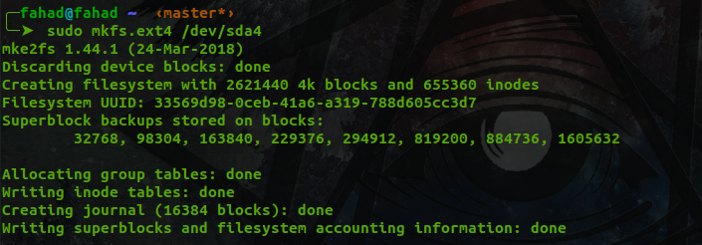

**Ques 6:-** Mount the created filesystem on /partition directory.

**Ans 6:-** First we have to make a directory in **/mnt** folder by **sudo mkdir /mnt/fahad**



Then we have to run mount command like **mount /dev/sda4 /mnt/fahad**

We can check the mount by **mount | grep fahad**

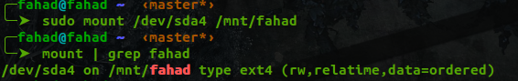

**Ques 7.** Difference between LVM and RAID.

**Ans 7.**

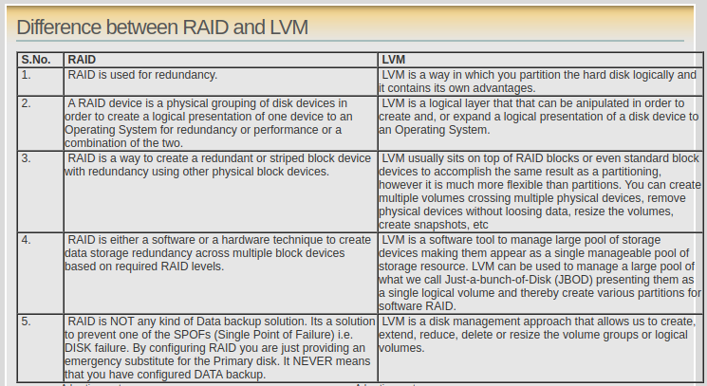

**Ques 8:-** Create a LVM

**Ans 8:-** To create a Logical Volume first we have to make a physical volume by

**sudo pvcreate /dev/sda4** to see the volume **sudo pvdisplay**

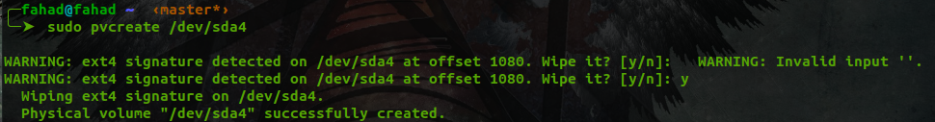

Then we have to create the volume group by

**sudo vgcreate vol_grp1 /dev/sda4**



Then we have to create the Logical volume by

**sudo lvcreate -l 20 -n logical_vol1 vol_grp1**

To see the Logical volume we have to run command

**sudo lvdisplay**

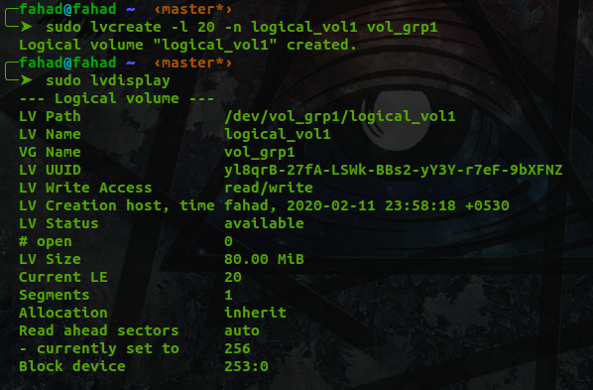

**Ques 10:-** Create a swapfile of 500Mb

**Ans 10:-**

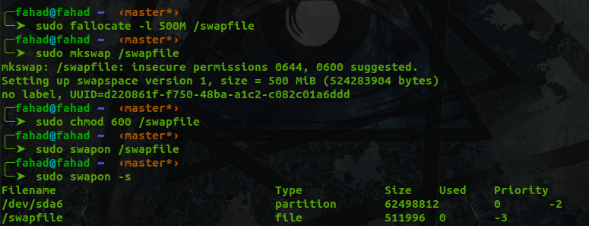

**Ques 11:-** Set setuid and setgid on two different file

**Ans 11:-** To **setuid** run command **sudo chmod u+s fahad.txt**

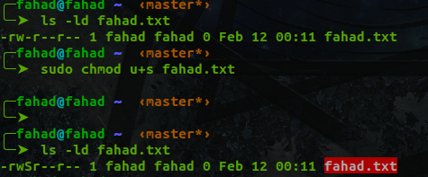

To **setgid** run command **sudo chmod g+s fahad1.txt**

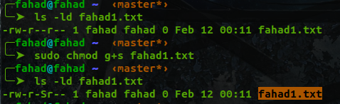

**Ques 12:-**What is the use of Sticky bit.

**Ans 12:-**Sticky bit is used on directories where each user have write permissions but only on their files, not on others.

An example of sticky bit is /tmp where each user can write its data but cannot write other user’s files.

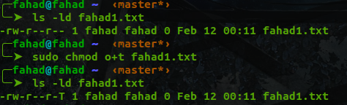

**Ques 13:-** Create a user and add it to one secondary group

Ans 13:- first we have to create a user with **sudo adduser newuser**

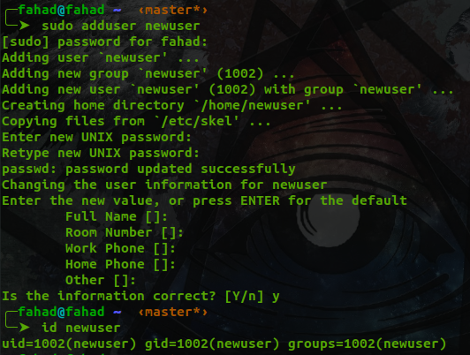

Here we can see that the user is added to newuser group

**By usermod -G <secondary group> <username>** it will add the secondary group to the user

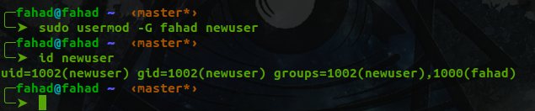

**Ques 14:-** Lock this user.

**Ans 14:- sudo usermod -L newsuser**  now if we have to check the status of the user we type **sudo passwd --status newuser**

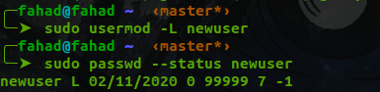

**Ques 15:-** Give this user full access (without password).

**Ans 15:-** By specifying the user in to the **sudoers** file we and setting all permission to **ALL** we can give full access to user

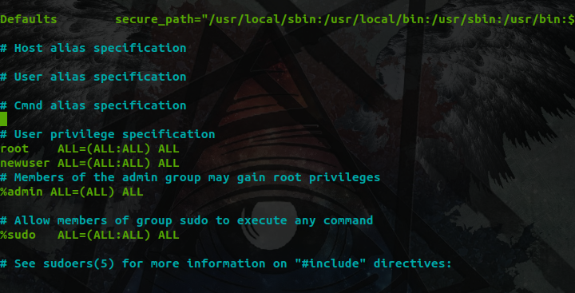

**Ques 16:-**Delete the create user after taking backup of it home directory.

**Ans 16:- By using deluser --remove -home --backup -to /tmp/userbackup newuser** its backup is being stored in the **/tmp/userbackup/newuser.tar** file.

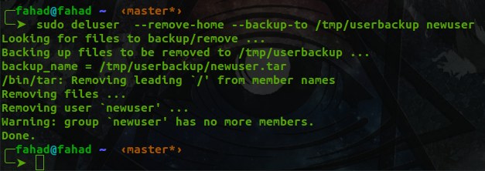

**Ques 17:-** Create a file with some content. Change all lower case letter to upper case letter and save output to another file using redirections.

**Ans 17:- tr** command is use to convert the text

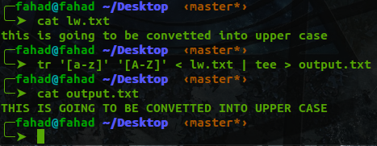

**Ques 18:-** Set nice value of a process to -1.

Ans :- first we have to list the processes with the **top** command



Run command

**Renice -n -1 -p 2227 -u fahad** it will change the nice value to **-1**



**Ques 19:-**Get list of all files used by “telnet”.

**Ques 20:-** Check if port 22 is listening using netstat and telnet command.

**Ans 20:-<USING TELNET> telnet <host IP> <port no.> if the port is down it won’t allow to connect**

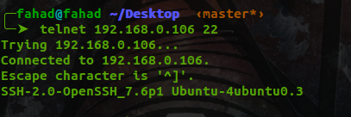

**<USING NETSTAT> sudo netsat -plnt | grep 22 it tells wether the port is listening or not**

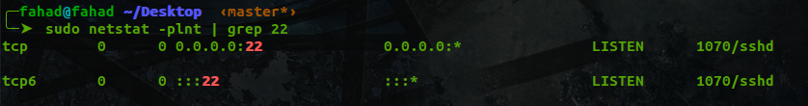

**Ques 21:-** Create a cron job which runs once in a week at 23:45.

**Ans 21:- crontab -u fahad -e** for creating the crontab

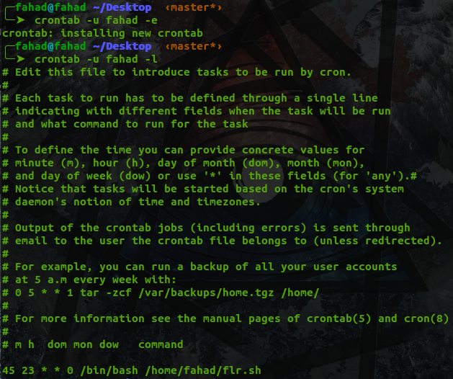

**Ques 22:-** Difference between dig and traceroute

**Ans 22:- Dig** is a DNS lookup utility. It performs DNS lookups and displays the answers that are returned from the name servers that were queried.

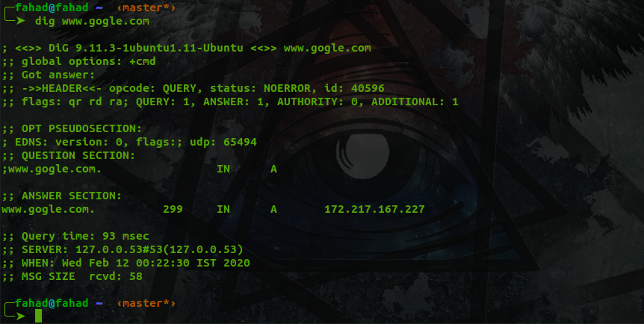

**Traceroute** tracks the route packets taken from an IP network on their way to a given host. It utilizes the IP protocol's time to live (TTL) field and attempts to elicit an ICMP TIME_EXCEEDEDresponse from each gateway along the path to the host.

